Student’s Name
Professor’s Name
Course
Date
Levi’s Blue Jeans
Levi Strauss, an enterprising immigrant who happened to have a few bolts of blue denim cloth on hand, recognized a need for strong work pants in the mining communities of California. He first designed and marketed "Levi's" in 1850, and they have stayed essentially the same ever since; there have been only minor alterations to the original design. Levi’s Blue Jeans have been useful to people in diverse ways (Lauren p.351). Foremost, they are being worn by people due to their fashionable status and their durability. Levi’s Blue jeans comes in different types and made of denims.
Stage One: Cotton
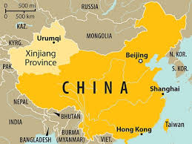
- Xinjiang Province
- This is where the cotton has been picked and is then processed and turned into cotton yarn.
- Cotton is the main component in making Levi Strauss Blue Jeans
Xinjiang province has optimum ecological conditions suitable for the growing of cotton. The cotton-planting area of Xinjiang is positioned at latitude 36°0′-46°2′ of the mid-latitude areas. It has a dry climate characterized with low rainfall amounts and more sunny days. There are several steps between ginned cotton (cotton after it has been picked from fields and processed) and cotton yarn (Mayer, and Mayer p.59). The incoming cotton is removed from tightly packed bales and inspected before undergoing a process known as carding. In this process, the cotton is put through machines that contain brushes with bent wire teeth. These brushes—called cards —clean, disentangle, straighten, and gather together the cotton fibers. At this point, the fibers are called slivers. Other machines join several slivers together, and these slivers are then pulled and twisted, which serves to make the threads stronger. Next, these ropes are put on spinning machines that further twist and stretch the fibers to form yarn.
Stage Two: Dying the Yarn - Synthetic Indigo
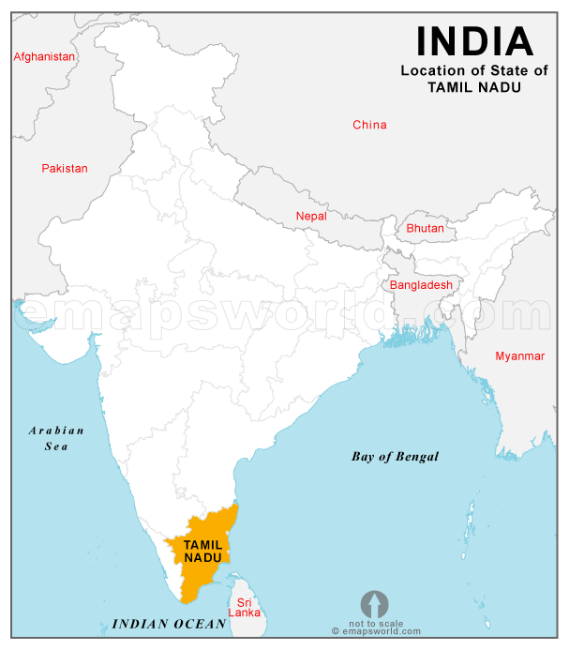
- Tamil Nadu India
- This is where the indigo is obtained from Indigofera tinctoria plants and then processed and dyed with chemically synthesized indigo before being woven.
Tamil Nadu India is a natural dark blue dye obtained from Indigofera tinctoria plants native to India. Some clothes are woven (see step 5 below) and then dyed, but denim is usually dyed with chemically synthesized indigo before being woven. Large balls of yarn, called ball warps, are dipped in the indigo mixture several times so that the dye covers the yarn in layers. (These many layers of indigo dye explain why blue jeans fade slightly with each washing.) Although the exact chemicals used in such dyeing procedures remain trade secrets, it is known that a small amount of sulfur is often used to stabilize the top or bottom layers of indigo dye. The dyed yarn is then slashed; that is, it is coated with sizing (any one of a variety of starchy substances) to make the threads stronger and stiffer. Once this operation is complete, the yarn threads are ready to woven with undyed filling yarn threads.
Stage Three: Leather - Labels
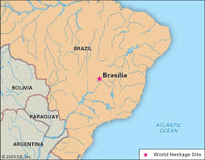
- Brasilia, Brazil
- This is where the labels get made through the multiple step leather making process.
Brazil ranks second in the world’s leather production, almost exclusively producing light leather from bovine hides and skins. Of the 1.7 billion square feet of leather produced in Brazil, less than 4% is sheep and goat leather (about 67 million square feet), and just over 2% (34 million square feet) is heavy leather - but even those small percentages add up to more square feet of leather hides and skins than the total amount produced by most countries in the world.
Stage Four: Manufacturing
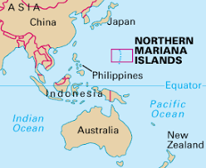
- Northern Mariana Islands
- This is where all of the components in making Levi Strauss Blue Jeans are put together to create the finished product.
Weaving the yarn:
The yarn is then woven on large mechanical looms. Denim is not 100 percent blue, as the blue dyed threads forming the warp (long, vertical threads) is combined with white threads forming the weft. The denim cloth is cut into pattern pieces from stacks 100 layers thick. High-speed cutting machines are used for this process. Once the pieces are cut, they are sewn into completed pairs of blue jeans. Sewing is done in assembly-line fashion using human-operated sewing machines (Woodward p.89). Because denim is woven with the blue threads packed closer together than the white threads and with the blue threads covering three out of four white threads, the blue threads dominate. (By examining a piece of denim closely one can detect the steep diagonal pattern that results from this process, which is known as a three-by-one right-hand twill weave.) Although mechanized looms make use of the same basic weaving procedure as a simple hand loom, they are much larger and faster. A modern "shuttle-less" loom (which uses a very small carrier instead of the traditional shuttle to weave the weft threads between the warp threads) may produce as much as 3,279 yards (3,000 meters) of cloth 3.28 or 4.37 yards (three or four meters) wide in a single week. As much as 1,093 yards (1,000 meters) of cloth may be rolled into a single huge bolt.
At this point the denim is ready for finishing, a term referring to a variety of treatments applied to cloth after it is woven. With denim, finishing is usually fairly simple. The cloth is brushed to remove loose threads and lint, and the denim is usually skewed in a way that will prevent it from twisting when it is made into clothing. The denim may then be sanforized, or preshrunk. Preshrunk denim should shrink no more than three percent after three washings.
Making the blue jeans:
Once the desired design is selected, patterns from the design are cut from heavy paper or cardboard. Up to 80 different sizes are possible from one pattern. The pieces of denim are then cut with high speed cutting machines from stacks 100 layers thick. Excluding rivets, buttons, and zippers, a pair of blue jeans contains about ten different pieces, from the pockets to the leg panels to the waistband and belt loops (Mayer, and Mayer p.72). The pieces of denim are ready to be sewn at this point. Sewing is done in an assembly line fashion, with rows of industrial human-operated sewing machines. Each sewer is assigned a specific function, such as making only back pockets. First, the various pockets and belt loops are assembled. Next, one sewer attaches the pockets to the leg seams, another then sews the leg seams together, and still another attaches the waist-band. Once the waist band is secure, the belt loops may be stitched on and the buttons attached. If the jeans include a zipper, it is then sewn into place, and the pants are hemmed. Finally, the rivets are placed in the appropriate places and the maker's label is sewn on last.
Some jeans are prewashed and/or stone-washed to alter the appearance or texture of the finished jeans. Prewashing involves washing the jeans in industrial detergent for a short time to soften the denim. Stone-washing also means washing the jeans, but pumice is added to the load, resulting in a faded appearance. Small stones (less than one inch [one centimeter] in diameter) produce an even abrasion, while large stones (about four inches [10 centimeters] in diameter) highlight the seams and pockets and produce a more uneven appearance.
The completed pair of blue jeans is I 0 then pressed. They are placed into a large pressing machine that steam irons the entire garment at once in about a minute. A size tag is punched into the material and the jeans are folded, stacked, and placed in boxes according to style, color, and size before being sent to the warehouse for storage (Tikkanen p.87). When the jeans are selected to be sent to a store, they are put in large shipping cartons and sent on freight trains or trucks.
Stage Five: Exporting
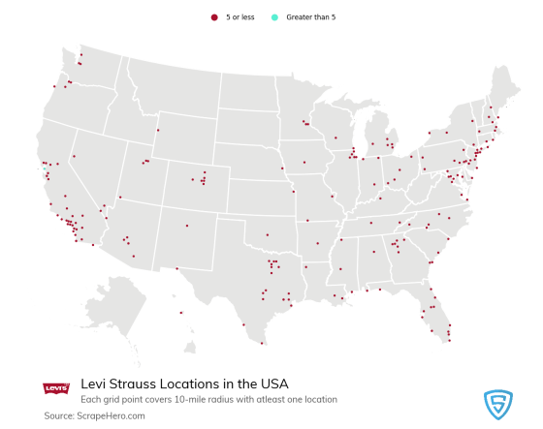
- Sold all throughout the United States of America
Conclusion
Xinjiang province is responsible for the highest production of cotton in China as it forms 50% of the cotton produced in the country. The harvest area of cotton in Xinjiang is expected to continue increasing. Xinjiang province has few fiber types. Contemporarily, 98% of the province’s raw cotton is mainly upland cotton, while sea-island cotton composes 2%. Xinjiang sea-island cotton possesses diverse characteristics such as long and thin fibers, astute uniformity, requisite ginning quality as well as few neps and impurities. Textile industries in China usually use high-quality Xinjiang sea-island cotton in making fabrics. One other finding is that Brazil’s hide and skin exports are likely to increase and ensure that the company grows its economy. The tanning industry of Brazil has astoundingly grown as it continues to bring forth new leather exhibits like ‘Design na Pele’. The country has taken much consideration on improving the quality of hides and skins sourced animals. With the increased preference of many people concerning the wearing of leather exhibits, the Brazilian industry is likely to rip more profits. Other countries producing leather designs ought to engage in the production of high-quality leather materials that are durable to woo more customers to purchase their products.
Cotton production in Xinjiang can be aided by myriad supporting technologies – the “dwarf, dense, early planting management mode. ‘Dwarf’ will ensure reasonable control of irrigation and fertilization in cotton fields. This helps in the prevention of disproportionate use of water by employing early top-dressing that is timely, adjusting the amount of water used in irrigation and nitrogen fertilizer used. “Dense” technique ensures rational close planting for the cotton to have high cultivation density. For the high harvest of cotton to be recovered from the planting field, there is a need to consider using high-quality cotton seeds along with following the required precision of sowing, such as spacing ranges of plants. There is a concern to be regarded by Xinjiang province during periods of extreme cold weather. Farmers need to adopt strategies that enhance the process of growing in cotton during such cold periods.

Works Cited
Mayer, David, and Helen Day-Mayer. "Blue Jeans Stage and Screen." Nineteenth Century Theatre and Film 46.1 (2019): 59-72.
Miller, Daniel, and Sophie Woodward. Blue jeans: The art of the ordinary. Univ of California Press, 2012.
Whitley, Lauren D. "Levi Strauss & Co."Encyclopedia of Clothing and Fashion, edited by Valerie Steele, vol. 2, Charles Scribner's Sons, 2005, pp. 351-353. Gale eBooks, https://link-gale-com.libproxy.uccs.edu/apps/doc/CX3427500366/GVRL?u=colosprings&sid=GVRL&xid=795c8ab2. Accessed 4 Nov. 2019.
https://www.britannica.com/topic/Levi-Strauss-and-Co

